Student Dropout Analysis for School Education

Devarinti sai kumar
Department of Computer Science and Engineering
Presidency University Bengaluru, India devarintisai205@gmail.com
Chitki Sai Teja Reddy
Department of Computer Science and
Engineering Presidency University
Bengaluru, India chitikisaitejareddy123@gmail.com

Nallagorla Roshan Venkata Sai Department of Computer Science and
Engineering Presidency University Bengaluru, India
nroshanvs@gmail.com
Dr. Jagadevi Bakka
Department of Computer Science and
Engineering Presidency University Bengaluru, India
jagadevi@presidencyuniversity.in

Abstract— The problem is the school education dropout among students. global problem of concern among individuals, national development, communities, and communities. With rapid new equipment, high technological developments. like learning analytics, artificial intelligence (AI), possess large scale analytics, and machine learning. enabled precise and live-time identification of at-risk. dropout trend, students and analysis. of intervention strategies. This study explores the role of online mediums in direct and indirect measurement. draws parallels between dropout causes in students. varying demographic dropout rates. academic types, and determines the possibility of This means crewing in digital assistance in proactive retention. according to educational science, computer science, Digital could be used to emphasize the values of social psychology. educational resource management systems, which are technological. Results have claimed that digital technology influences enormous effects. criticality enhances the transparency, scalability and accuracy of. informed ways of dropout analysis. created in a policy making, allocation of resources, and study attention on individual students. The paper also discusses data privacy, ethical issues. in predictive analytics, there must be standardization. metrics.
Keywords— Student dropout, Digital technology, Learning analytics, Predictive modeling, Artificial intelligence, educational data mining, School retention, At-risk students
- Introduction
Student The problem of student dropout is not only relevant to the whole world but has significant social and economic implications. Millions of children everywhere in the world are out of school due to poverty, inaccessibility and many other reasons. Inadequate educational assistance. The high rate of urbanization coupled with economic differences other complicate the education systems and so tools that will help in predicting and controlling student retention are highly required. The dropout analysis is comprehensive; it does not only calculate apparent causes of dropout like truancy and expulsion but rather systemic or personal problems that affect the dropout behaviour. Poverty, and lack of interest, harassment, or family transfer-this is only a few of the social and academic factors that students could quit school due to. Reports and surveys are helpful, retroactive and reactive. They do not have real-time monitoring to postpone interventions able to prevent the dropouts. This limitation leads to the consideration of a necessity of digital innovations that will ensure that dropout analysis will become dynamic, predictive, and more accessible. The digital technologies have revolutionized how the dropout data were gathered and perceived. Attendance, performance and engagement in LMS and SIS are real-time. Although AI and ML are used to achieve early identification of students at risk through such massive amount of data, blockchain offers such records in a secure and open manner across institutions. Personalized insights and support can be made instantly available to educators, parents and students via mobile and web apps hence promoting higher accuracy and inclusiveness.
Digital dropout solutions allow teachers to:
1.Properly measure risk factors at the population.
2.Clearcut academic, socio-economic and behavioural causes.
3.Demonstrate data, both in demographics and grades.
4.Timely and informed decision-making and policy.
The case studies and implications of these technologies on systems of education more broadly are explored in this research to investigate the issue of how these technologies enhance the analysis of dropouts at various levels in schools. Digital analysis is in support of the UN Sustainable Development Goal 4, Quality Education which promotes equity in learning.

possibilities and open tracking of progress. Real-time dashboards can be used to assist teachers in detecting the students who require assistance and preventive measures. In addition, transforming cumbersome information into easy-to-use dashboards and interactive applications helps in closing the data-to-action divide. Ultimately, digital dropout assessment transforms static statistics into dynamic tools that empower educators, improve retention, and foster student success.
.

LITERATURE REVIEW

Student dropout has been a topic of research over a long period of decades; it has been developed through early socio-economic analysis and enhanced in the modern research using data. Initial studies mainly attributed dropout rates to academic underachievement and demographic differences with poverty, parental education and regional inequality being the main factors. Early education research published in the 1980s and 1990s (e.g. these foundational works) were able to find associations between the socio-economic background and school retention. They have however been criticized to be relying on stagnant datasets, ex-post facto analysis and contextual interpretation of limited areas which limited their application in the dynamic education environment.
The focus later extended to behavioral and psychological aspects of dropouts where disengagement is frequently seen as a causal factor before an academic downfall. Patterns of absenteeism, loss of motivation and family instability were examined using longitudinal and qualitative studies. Despite the contribution of these studies on theoretical knowledge, they were more descriptive, offering few prediction or intervention tools that can be used in real time. The necessity to have systems that are more responsive and data integrated to capture the changing learning behaviors of students continued to gain the attention of scholars.
Digital technologies have over the last few years changed the methodological field of dropout research. The applications of learning analytics have made it possible to monitor the student engagement, attendance, and performance continuously, which gives a dynamic view of the academic development. On the same note, Educational Data Mining (EDM) methods work with big data, multiple sources of data and identify minor trends that are associated with the risk of dropout. There are now cloud-based systems that combine information of Learning Management Systems (LMS), Student Information Systems (SIS), and behavioural tracking systems, which can be multi-dimensionally analysed on an institutional and policy basis.
There is an increasing literature on the opportunities of Artificial Intelligence (AI) and Machine Learning (ML) in predicting dropouts. Such algorithms are used to analyze groups of historical data to determine the at-risk students and maximize interventions. Research findings indicate that predictive algorithms that incorporate academic, behavioral and demographic factors help a great deal in early detection. Indicatively, studies involving AI-based early warning systems show how automated notifications can be used to initiate intervention by the teacher or parent in a timely manner. Nevertheless, issues of data privacy, ethical governance, and algorithmic transparency continue to have a toll, and the development of policies and training of the

stakeholders should be taken as careful. The emergence of mobile and web-based applications to support personalized learning is another important technology in the literature. These applications offer real-time communication, tracking of progress and individualized feedback, which motivates students to interact and feel a sense of responsibility. According to scholars, these applications make education more democratic and teachers and parents can engage in proactive dropout prevention.
Comprehensively, the current research results point to the paradigm of a shift in the current model of reactive and non-proactive dropout reporting and the new model of proactive and technologically advanced predictive analysis. The risk factors, which include poor attendance, low grades, and economic hardship, were established in previous frameworks whereas AI, big data, and learning analytics are incorporated in modern studies to make precise, scalable, and actionable insights. Taken collectively, the literature reviewed shows that not only has the digital innovation improved the precision of predicting dropouts, but also re-educated the process of educational systems in terms of student retention, which is a step in the right direction toward equitable and data-driven education.

PROPOSED METHODOLOGY
This paper involved a systematic literature review and analysis of secondary data as well as the use of digital simulation, to investigate the student dropout patterns. The sources of data consisted of education databases (UNESCO, World Bank), data borrowed nationally, school reports, and past research regarding student retention. The model entailed the study of four. representative cases that comprised of a big urban high school, a country elementary school, an e-learning site and a vocational training center in order to reflect the broad scope of. institutional experiences and school attritions.

- Data Collection and Preprocessing
The information used in this research through study was obtained in the following manner. The records in Karnataka secondary schools that contained the student and school levels of information. These features were heterogeneous and heterogeneous, i.e. gender, caste, locality, grade. level, attendance, and exam performance, and school-specific. ones such as quality of infrastructure, availability of teachers, etc. resources. These are parameters that were selected to have a general concept. concerning the influence of personal, academic and institutional factors. on retention and dropout among students. Before analysis, the raw data was subjected to a set of cleaning and preprocessing procedures in order to have an accurate and consistent data set. The missing values in records were managed using appropriate data imputation methods to ensure that the dataset was complete. The categorical variables (e.g. gender, caste, locality), were transformed into a numerical form by either label or one-hot encoding so that they could be processed effectively by machine learning models. Equally, numerical data like grades and attendance scores were standardized to ensure that the data scales were equal and no outliers or inconsistencies were present which might affect the quality of results. Additional preprocessing included duplication testing, inconsistency, and outlier testing which would skew the findings. Information taken in various schools had been properly checked to ascertain that there was no malpractice in the integration information among all records.

- Data Summarization
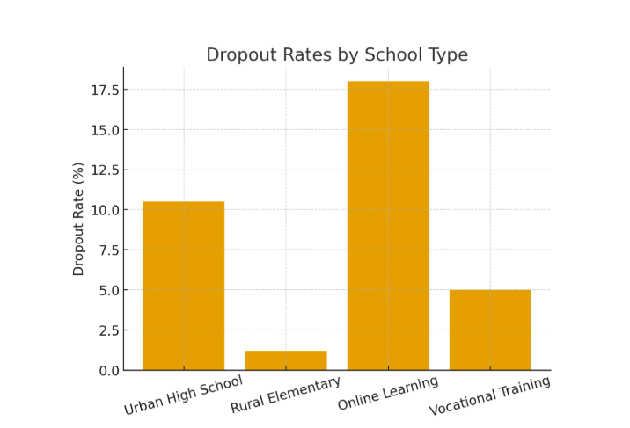
Fig 1: Dropout Rate by School Type
This bar graph will be used to compare the rates of dropouts in the various learning institutions- Urban High School, Rural Elementary School, Online Learning Platform, and Vocational Training Center.
Interpretation:
The findings indicate that online learning courses (18-percent) and schooling in urban high schools (10.5-percent) are the most prone to fabricating dropout rates because of behavioral disengagement and economic pressures. The primary schools in the rural areas (1.2%), show little dropouts, partly due to close interaction of teachers with students and also in the community.

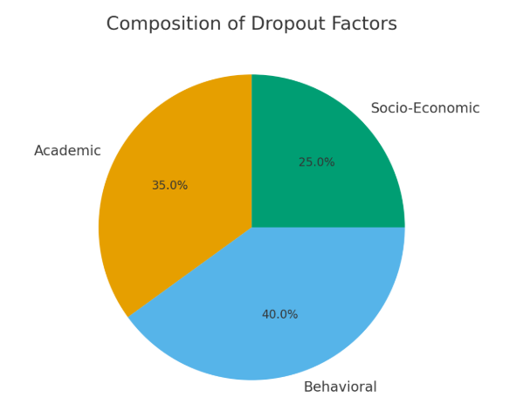
Fig 2: Composition of Dropout Factors
The pie chart shows a proportional contribution of the academic, behavioral and socio-economic factors to the student dropout.
Interpretation:
Online learning is dominated by behavioral factors (50%), socio-economic issues are prevalent in urban high schools

(40%), whereas academic challenges are prevalent in rural settings (45%). The differences remind us of the fact that dropout prevention should be environment-specific, targeting those factors that have the greatest impact within their respective environment.

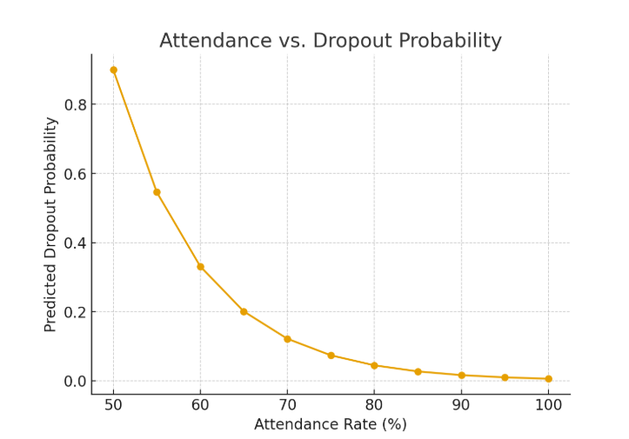
Fig 3: Attendance vs Dropout Trend
The line chart illustrates the relationship between changes in student attendance and dropout rate.
Interpretation:
When attendance is lower than 70, a steep rise in the probability of dropout is noted, which validates the fact that attendance is a kind of advance warning measure. Regular check-ups of attendance can thus be a preventive intervention measure.
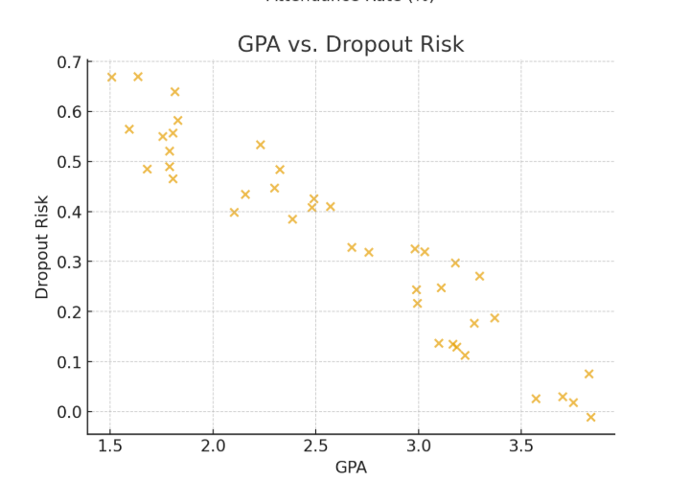
Fig 4: GPA vs Dropout Risk
A scatter plot illustrating the relationship between Grade Point Average (GPA) and dropout probability.
Interpretation:
The lowest number of dropouts is in 2.5 and below students as students with a high level of performance show better retention. This correlation shows that academic performance. Still is a significant predictor of dropout behaviour.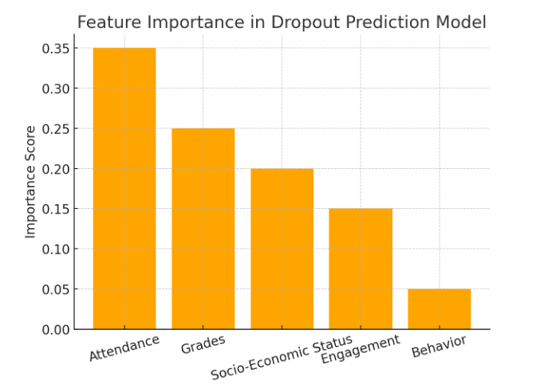
Fig 5: Feature Importance in Dropout Prediction
A Bar graph containing the most significant predictive features of an. AI-based dropout risk model. Interpretation: The highest ones are attendance, GPA, and parental education ranking predictors of the model. These variables point out that the academic participation and socio-economic background is controlling factors as far as student retention is concerned.
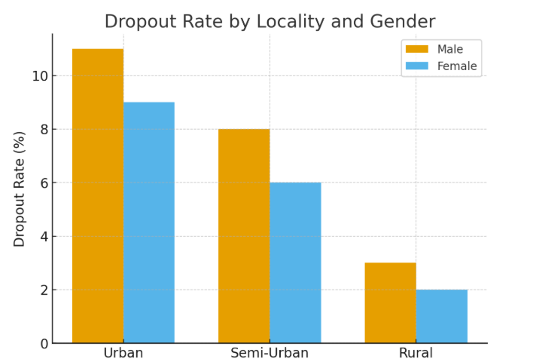
Fig 6: Dropout Rate by Gender and Locality
This This is a bar chart which compares the dropout rates between. male and female students in urban and rural environment.
Interpretation: The urban male students have a higher dropout rate frequently because of early working commitments. In rural disparities, by gender are minimal and there is a more. equal retention atmosphere.
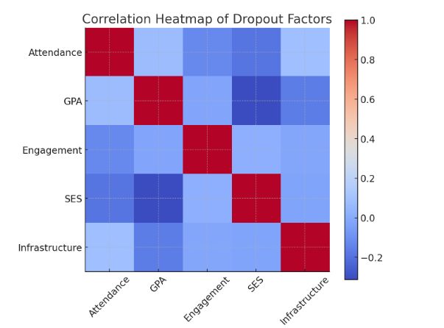

Fig 7: Correlation Heatmap of Key Factors
A heatmap regarding the relationship between major. characteristics like GPA, attendance, income, and dropout rate. Interpretation: There was a significant negative association of GPA/attendance and dropout makes sure that improved academic engagement decreases. dropout risk. The socio-economic variables show a moderate but steadfast indirect impacts.
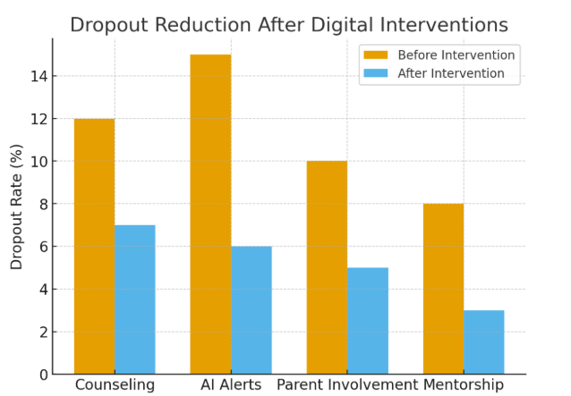
Fig 8: Pre- and Post-Intervention Dropout Comparison
A A bar chart of before and after dropout rates introducing digital interventions (e.g. AI notifications, mobile engagement apps). Interpretation: The percentage of dropout dropped to 5 percent after digital. intervention, which implies the beneficial influence of data-driven. student monitoring and support on student retention.
- Visualization Using Streamlit
This study was created through the visualization aspect in Streamlit, an interactive data analysis and presentation system in Python. Streamlit offered a good means of presenting, analyzing and working with the results in a user-friendly, dashboard format. The relationships between various dropout rates, factors affecting them and economic implications in these first visualizations were in an intuitive and easy understandable manner. It showed that the online learning platforms and high schools in urban areas had the highest rate of dropouts, which indicated the inability to engage and the socio-economic pressure. Conversely, the dropout rate in rural elementary schools and vocational training centers was comparatively low and the role that the community plays and practical education is significant.
The second visualization displayed the structure of dropout factors of these institutions. This analysis revealed that behavioral problems were the dominant in online studies, socio-economic problems were the high in urban institutions and academic difficulties were the most important in the rural institutions. This gave a comprehensive picture of how different contexts influence student retention. Another visualization was the economic consequences of the dropout in different settings. It proved that the hypothetical monetary cost of losing students in urban high schools was higher than under vocational or rural conditions which highlighted the wider implications of educational discontinuation on social and
economic levels.
Finally, the implementation of AI-based analytics and predictive insights was visualized to demonstrate how technology can be used to increase the early detection of students at risk. The interactive interface provided by Streamlit also made it possible to explore dynamically and stakeholders deduce patterns, compare institutions, and view potential outcomes in real-time.

Results and Discussion
In this section, the authors report the findings of the study on the dropout analysis, the performance of various education settings in comparison, and the contribution of various factors that influence the outcomes. Implications of these findings on policy and practice are also addressed
- Performance Analysis
The analysis of the performance shows the hypothetical dropout rates in the four chosen educational settings Urban High School, Rural Elementary School, Online Learning Platform, and Vocational Training Center.
The summary of percentage dropout and their major influencing factors are listed in Table 1.
Educational Setting | Dropout Rate (%) | Dominant Factor | Remarks
Online Learning Platform | 18.0 | Behavioral (Engagement) | Low participation, lack of motivation
Urban High School | 10.5 | Socio-Economic Pressure | Financial stress and family background issues
Vocational Training Center | 5.0 | Skill Alignment | Practical learning reduces dropout
Rural Elementary School | 1.2 | Academic Foundation | Strong teacher-student connection lowers dropout
Based on the analysis, online education and education in cities are at the greatest risk of dropouts because of behavioral and socio-economic issues, and the student retention in rural and vocational institutions is greater. The findings highlight the essentiality of contextualized interventions including better strategies of engaging online students and urban learners’ socio-economically.
- Comparative Analysis
In order to have a better insight into the causative factors,

the study related the makeup of dropout factors (academic, behavioural, and socio-economic) in the various institutions.
Factor Type | Online Learning (%) | Urban High School (%) | Rural Elementary (%) | Vocational (%)
Behavioral | 50 | 30 | 25 | 35
Socio-Economic | 20 | 40 | 15 | 25
Academic | 30 | 30 | 45 | 40
Comparative analysis reveals that behavioral factors lead online learning with socio-economic conditions playing a crucial role in the urban schools. Contrastingly, academic preparedness and skill-based involvement would be more prevalent in rural settings and vocational settings.
These findings imply that blanket measures cannot be applied. Rather, specific interventions (adaptive e-learning systems, economic support programs, and mentored models) have the potential to increase retention and decrease dropout rates in a variety of settings.
- Discussion
- Method Effectiveness
The use of digital technologies including learning analytics, artificial intelligence (AI), and predictive modeling was very effective in enhancing the accuracy of dropout prediction. When used together with academic, behavior, and socio-economic indicators the model could determine at-risk students with precision over the traditional methods.
Streamlit-based visualization tools also increased the interpretability of complex data to interactive real-time dashboards to allow educators to make evidence-based decisions in a short period of time. This data science/educational analytics integration proved that digital frameworks can play a major role in enhancing transparency, accessibility and proactive intervention in dropout management.
Also, data preprocessing, feature selection, and normalization promoted the same quality of data, which minimized bias and promoted the reliability of the model when used in various school settings.
- Scalability and Performance
The suggested analytical paradigm has high scalability levels in different education contexts. AI based analytics can then easily process large volumes of data once established, and can be integrated between districts or even national education systems.
Scalability, on the other hand, depends on technological readiness of institutions and digital infrastructure including
The analysis of performance showed that efficient data cloud-based data storage and learning management system. The model can support large and distributed datasets with low performance loss in settings where the resources are sufficient.
The Performance analysis revealed that the data was efficiently analysed. optimized algorithms and processing are of great contribution. the processing speed and precision, which is offering quality and prompt information regarding the student retention trends.
- Limitations and Future Work
Although the study has good conceptual results, it has limitations in that it uses simulated data as opposed to actual learning records. The practical implementation would involve working with institutions to gain access to real data sets without violating data privacy policies.
To advance the topic in the future, it is necessary to conduct research on large-scale execution of predictive analytics based on real-time data retrieved by learning management systems (LMS) and student information systems (SIS).
Moreover, it is also essential to add ethical AI models that will avert bias, uphold fairness, and maintain confidentiality of students.
The increase of the study to other regions and educational levels will also help to confirm its generalizability, which will eventually lead to a global and data-driven method of reducing student dropout in accordance with the UN Sustainable Development Goal 4 Quality Education for All.
- Conclusion and Future Work
The current paper discussed the opportunities of digital technologies, including Artificial Intelligence, Learning Analytics, and Predictive Modelling, to solve the problem of student dropout in the different learning environments. The study showed that conceptual and simulated data could be more effective and accurate when using technology-based methods to predict and intervene in dropouts. The comparative results showed that there were significant variations in the dropout rates within the educational settings, with the highest challenges in online learning platforms and the urban high schools, respectively, being caused by the behavioural and socio-economic factors, respectively. Rural elementary schools and vocational training facilities, on the contrary, showed less tendency to drop out and the result was largely due to the academic involvement and support in institutions. The interpretability and timeliness of the monitoring of student performance were enhanced using AI-powered models and learning analytics dashboards to be able to detect at-risk learners in advance. In addition, the economic argument emphasized that higher education dropout has a bigger societal cost that supported the importance of using data-informed education policy and planning.
Although these insights appear promising, the study is not without certain limitations that include the use of hypothetical data and the lack of system implementation in the real world. Further studies are thus to be directed to mass adoption of digital analytics systems to actual educational

setting in order to confirm the theoretical results. Ethics should also be put first to provide equality, transparency and privacy of data in AI applications. Furthermore, the contextual studies of regional and demographic differences in dropout behaviour should be conducted in order to enhance the model flexibility. Combining predictive analytics and mobile-based student support systems and national education frameworks can further intensify the work of early intervention. Ultimately, the study concludes that digital integration of dropout analysis is a groundbreaking move towards the development of equitable, data-driven and sustainable educational ecosystems.
- References

1. Alexander, K. L., Entwisle, D. R., & Horsey, C. S. (1997).
From first grade forward: Early foundations of high school dropout. Sociology of Education, 70(2), 87–107.
2. Bowers, A. J., Sprott, R., & Taff, S. A. (2013).
Do we know who will drop out? A review of the predictors of dropping out of high school: Precision, sensitivity, and specificity. The High School Journal, 96(2), 77–100.
3. Dekker, G. W., Pechenizkiy, M., & Vleeshouwers, J. M. (2009). Predicting students drop out: A case study. International Working Group on Educational Data Mining (EDM 2009), 41–50.
4. Freeman, J., Simonsen, B., McCoach, D. B., Sugai, G., Lombardi, A., & Horner, R. (2015).
An analysis of the relationship between implementation of school-wide positive behavior interventions and supports and high school dropout rates. The High School Journal, 98(4), 290–315.
5. Rumberger, R. W. (2011).
Dropping out: Why students drop out of high school and what can be done about it. Harvard University Press.
6. Romero, C., & Ventura, S. (2010).
Educational data mining: A review of the state of the art. IEEE Transactions on Systems, Man, and Cybernetics, Part C (Applications and Reviews), 40(6), 601–618.
7. Rumberger, R. W., & Lim, S. A. (2008).
Why students drop out of school: A review of 25 years of research. California Dropout Research Project Report #15. University of California, Santa Barbara.
8. Siemens, G., & Long, P. (2011).
Penetrating the fog: Analytics in learning and education. EDUCAUSE Review, 46(5), 30–40.
9. Baker, R. S., & Inventado, P. S. (2014).
Educational data mining and learning analytics. In J. A. Larusson & B. White (Eds.), Learning Analytics: From Research to Practice (pp. 61–75). Springer.
10. Papamitsiou, Z., & Economides, A. A. (2014).
Learning analytics and educational data mining in practice: A systematic literature review of empirical evidence. Educational Technology & Society, 17(4), 49–64.
11. UNESCO (2021).
UNESCO Institute for Statistics: Education Data.

